H.T No
Regulations:
A22

Sreenidhi Institute of Science and Technology
(An Autonomous Institution)
Code No:9A201 Date: 09-August-2024 (FN)

B.Tech I-Year II- Semester External Examination, August-2024 (Regular & Supplementary)
ELECTRICAL CIRCUITS AND NETWORKS-I (EEE)

Time: 3 Hours Max.Marks:60

Note: a) No additional answer sheets will be provided.
b) All sub-parts of a question must be answered at one place only, otherwise it will not be valued.
c) Missing data can be assumed suitably.
Bloom's Cognitive Levels of Learning (BCLL)

Remember | L1 | Apply | L3 | Evaluate | L5
Understand | L2 | Analyze | L4 | Create | L6

Part - A Max.Marks: 6x2=12

Answer all QUESTIONS, EACH QUESTION CARRIES 2 MARKS.

 |  | BCLL | CO(s) | Marks
1 | Explain independent and dependent sources with examples. | L2 | CO1 | [2M]
2 | Define the following terms w.r.t network Graph theory: i) Connected graph ii) Tree iii) Links. | L1 | CO2 | [2M]
3 | What is the Coefficient of coupling? | L2 | CO3 | [2M]
4 | Define Peak factor and Form factor | L1 | CO4 | [2M]
5 | Write the differences between series and parallel resonance. | L1 | CO5 | [2M]
6 | State and explain Norton's theorem | L1 | CO6 | [2M]

Part – B Max.Marks: 6x8=48
ANSWER ALL QUESTIONS. EACH QUESTION CARRIES 8 MARKS.

 |  | BCLL | CO(s) | Marks
7. | - Using mesh analysis, Evaluate the current through the 5Ω resistor of the circuit as shown in Figure.  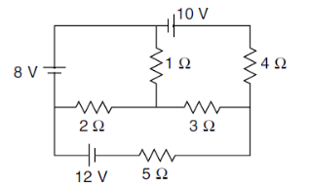  b) Illustrate the necessary equations for delta-to-star conversion. | L5 | CO1 | [8M]
 | OR
8 | - Explain the principle of source transformation with a suitable example.  (b) Find the equivalent resistance between A and B in the fig using star-delta transformation technique.  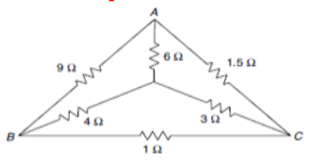 | L2  L5 | CO1 | [8M]
9. | The graph of a network is shown in Fig. Write the (a) incidence matrix, (b) tie-set matrix, and (c) f-cut-set matrix.  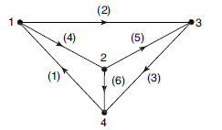 | L4 | CO2 | [8M]
 | OR
10 | For this network shown in Fig., write down the tie-set matrix and obtain the network equilibrium equation in matrix form using KVL. Calculate the loop currents and branch currents.  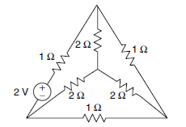 | L5 | CO2 | [8M]
11 | - Compare electric and magnetic circuits, clearly stating their similarities and dissimilarities.  - Find the equivalent inductance of the network shown in Figure.  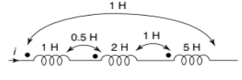 | L3 | CO3 | [8M]
 | OR
12 | Two coils with a coefficient of coupling of 0.6 between them are connected in series to magnetize in (a) same direction and (b) the opposite direction. The total inductance in the same direction is 1.5 H, and in the opposite direction is 0.5 H. Find the self-inductance of the coils. | L4 | CO3 | [8M]
13 | Derive the RMS ,Average values ,form factor and peak factor of the sinusoidal waveform of AC supply. | L1 | CO4 | [8M]
 | OR
14 | A resistor of 150Ω, inductance of 200mH and a capacitance of 10µF are connected in series across 500V, 150Hz supply. Determine the following (i) Impedance (ii) current flowing through the circuit (iii) power factor (iv) voltage across R,L &C (v) power in watts. | L3 | CO4 | [8M]
15 | Construct the locus diagram for parallel LC circuit with variable X_{L} and X_{c}? | L3 | CO5 | [8M]
 | OR
16 | Given a series RLC circuit with with R=10ohms, L=1mH and C=1µF is connected across a sinusoidal source of 20V with variable frequency. Find (i) The resonant frequency (ii) Q factor of the circuit at resonant frequency (iii) Half power frequencies | L5 | CO5 | [8M]
17 | Calculate the current flowing through the 2Ω resistor shown in Figure 3 using Thevenin’s theorem.  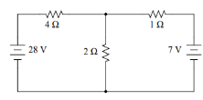 | L5 | CO6 | [8M]
 | OR
18 | Calculate the current ‘i’ in Figure shown below using the superposition theorem.  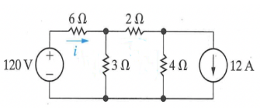 | L5 | CO6 | [8M]

-- 00 -- 00 –

